**WEEK - 2**

**SKILL : PL/SQL Programming Mandatory Hands-on exercises**

**Exercise 1: Control Structures**

**Scenario 1:** The bank wants to apply a discount to loan interest rates for customers above 60 years old.

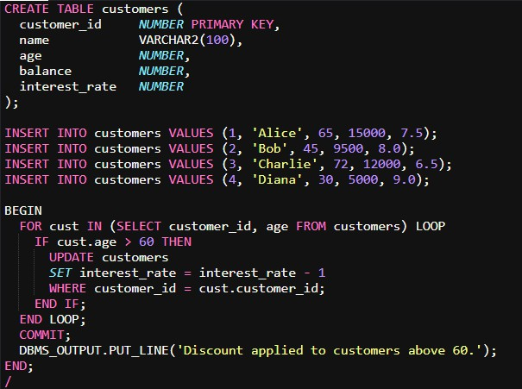**Code:**

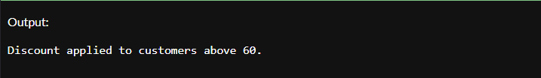**Output:**

**Scenario 2:** A customer can be promoted to VIP status based on their balance.

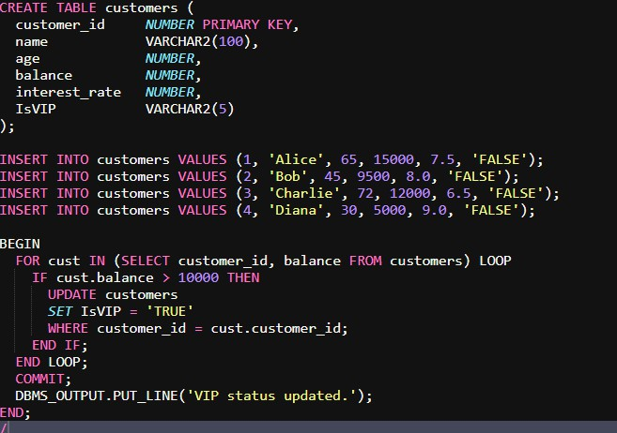**Code:**

**Output:**

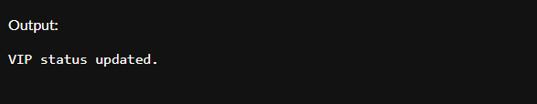

**Scenario 3:** The bank wants to send reminders to customers whose loans are due within the next 30 days.

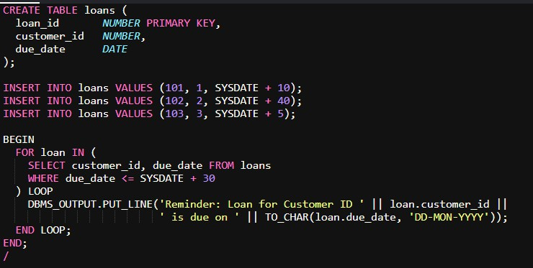**Code:**

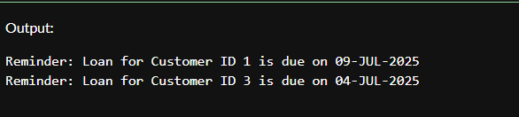**Output:**

**Exercise 2: Stored Procedures**

**Scenario 1:** The bank needs to process monthly interest for all savings accounts.

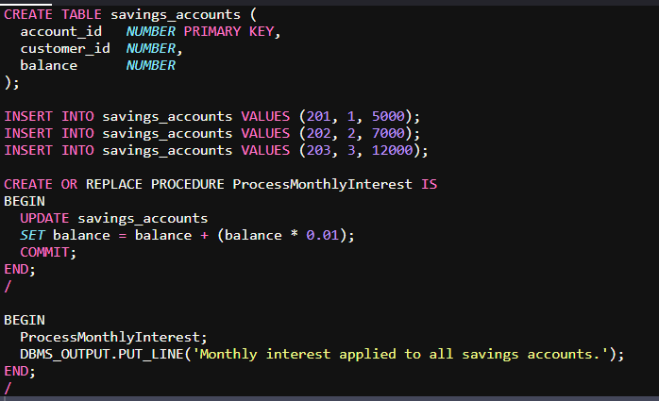**Code:**

**Output:**

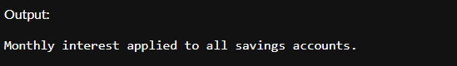

**Scenario 2:** The bank wants to implement a bonus scheme for employees based on their performance.

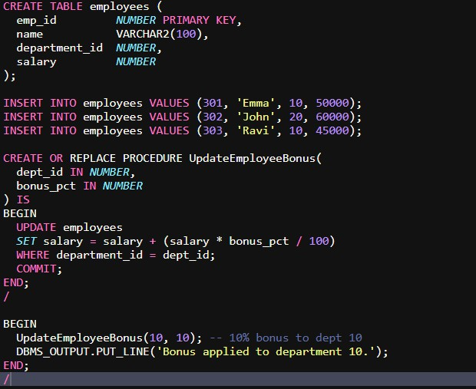**Code:**

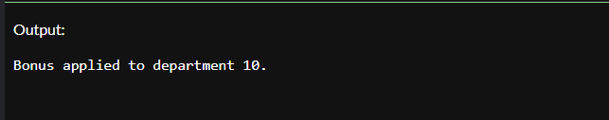**Output:**

**Scenario 3:** Customers should be able to transfer funds between their accounts.

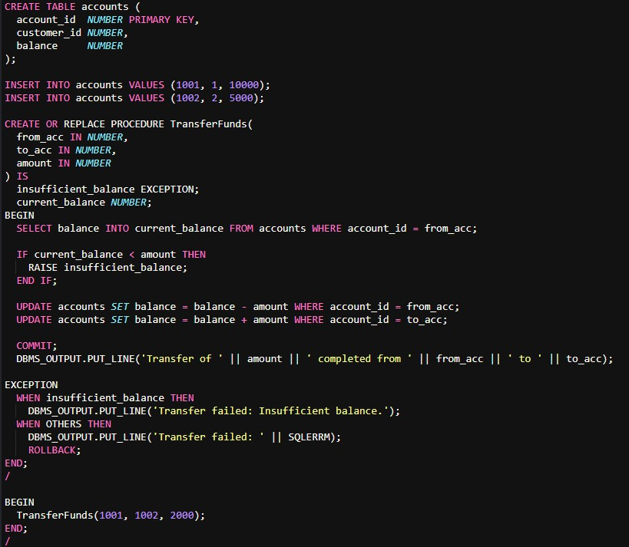**Code:**

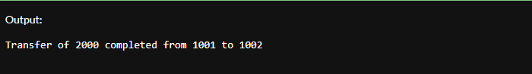**Output:**